Software Requirements Specification



Recommendation of Doctors and Medicines using Review Mining

1. **Requirement Analysis:**

**What problems we are trying to solve?**

* Medical data are an ever growing source of information generated from hospitals consisting of patient records in the form of hard copies which can be made easier and convenient by using QR code of the patient details.
* Our aim is to build a Health-care Portal system which will provide the features like clinical management, patient records, disease prediction and generate QR code for every patient as per there updated disease information.

1. **Functional Specification:**

**How the system will behave:-**

**1. Patient:**

* Registration
* Login
* Logout

**A. Registration**

* The patient will register to the system with normal information.
* At the time of registration patient will enter valid Email-ID and receives QR code on his Email-ID which in encrypted format.

**B. Login**

* For login to the system, patient will enter the Email and password, if entered details are correct then the system will redirect him to home page otherwise it will shows an error message.

**After Login:**

1. Patient will enter the symptoms.
2. Then patient get disease result and generate QR code and sent to patients Mail ID.
3. Patient will search for doctor as per disease shown by system.
4. Patient will get result of doctors.

**C. Logout**

* Patient logout the account from system.

**2. Doctor**

* Registration
* Login Scanner
* Logout

**A. Registration**

* Doctor will register to the system with normal information.

**B. Login into Scanner.**

* Patient gives QR code to the doctor which is received in his mail ID.
* Doctor login into scanner.

**After Login:**

1. Doctor scans and decrypts the QR code.
2. Then gives prescription and medicine in QR code format and send to patient Mail ID.
3. The alert will be generated and send to user on his profile regarding prescription.

**C. Logout**

* Doctor Logout the account from system.

**3. Pharmacist**

* Login Scanner
* Logout

A. **Login into Scanner.**

* Patient gives prescription QR Code which is received in his mail ID.
* Pharmacist login into scanner.

**After Login:**

1. Pharmacist scans and decrypts the QR code.
2. Then give medicine to patient.

**B. Logout**

* Pharmacist Logout the account from system.

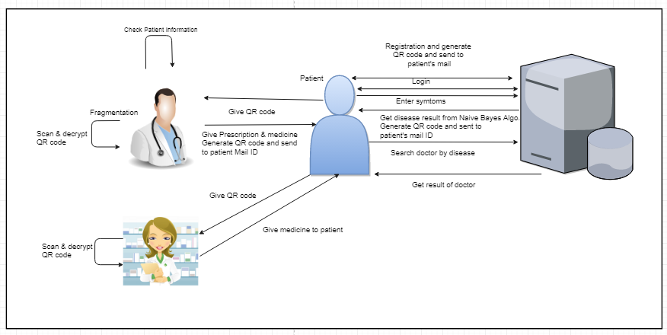

1. **External Interface Specification:**

* **User Interface:**
* Front-End Software: Java/Android
* Back-End Software: MYSQL,Java.
* **Hardware Interface:**
* Windows.
* A browser which supports HTML and Java script.
* **Database Backend:**
* MySQL.

1. **Technical Specification:**

* Operating System :Android
* Coding Language : JAVA/J2EE, Hibernate
* IDE : Eclipse
* Web server : Apache Tomcat 7
* Front End: JSP, CSS, Android.
* Back End: MySQL as database server.